Be Proactive! Promote Early Detection of Ocular Disease

Healthy vision is an amazing gift. Imagine what it would be like to lose your vision and the devastating impact it would have on your life. Many eye diseases can rob you of your sight. Fortunately most cases of severe vision loss and blindness can be prevented with early detection, and today there are options available to help identify disease early.

Our doctors are excited to offer new and advanced tests to evaluate the health of your eye and help detect glaucoma and disease of the retina. In most cases this will take the place of dilation of the eyes. The Cirrus HD-OCT performs a simple yet powerful test which helps doctors identify early signs of eye problems which can lead to irreversible blindness. The test is quick, completely painless, and does not touch the eye. The Optos OPTOMAP ultra-wide digital retinal imaging system captures more than 80% of your retina in one panoramic image. Traditional methods typically reveal only 10-12% of your retina at one time.

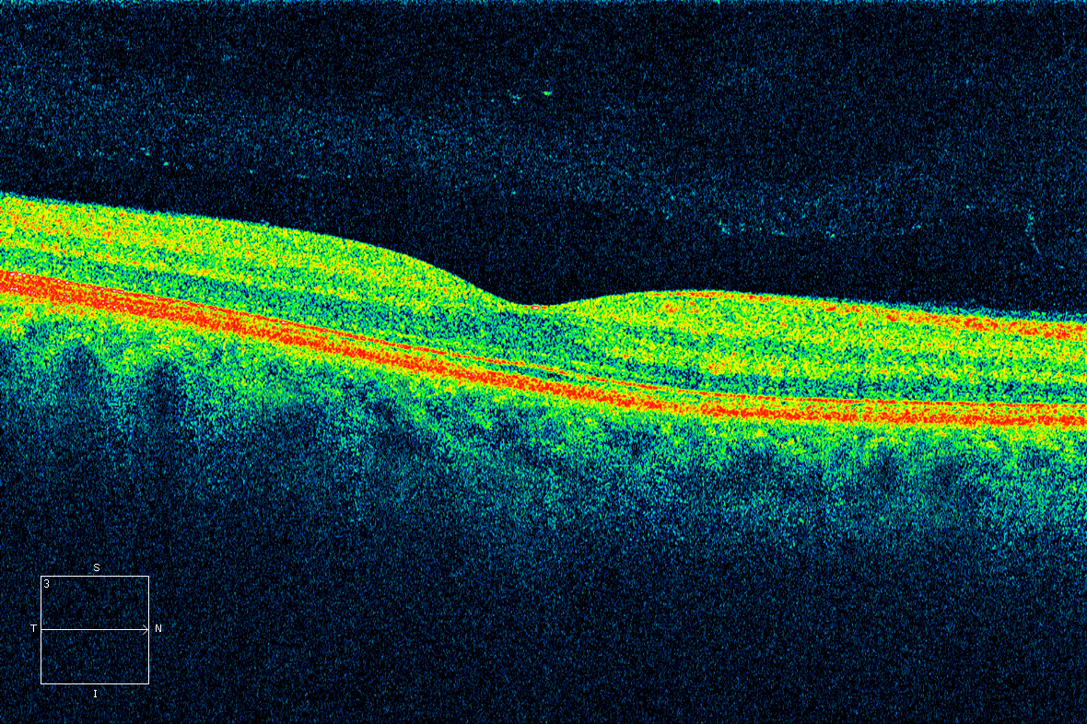
There are many diseases that tend to progress without any symptoms in the early stages. The early detection of any retinal abnormality is crucial to maintaining your ocular and systemic health.
Image of a healthy Retina

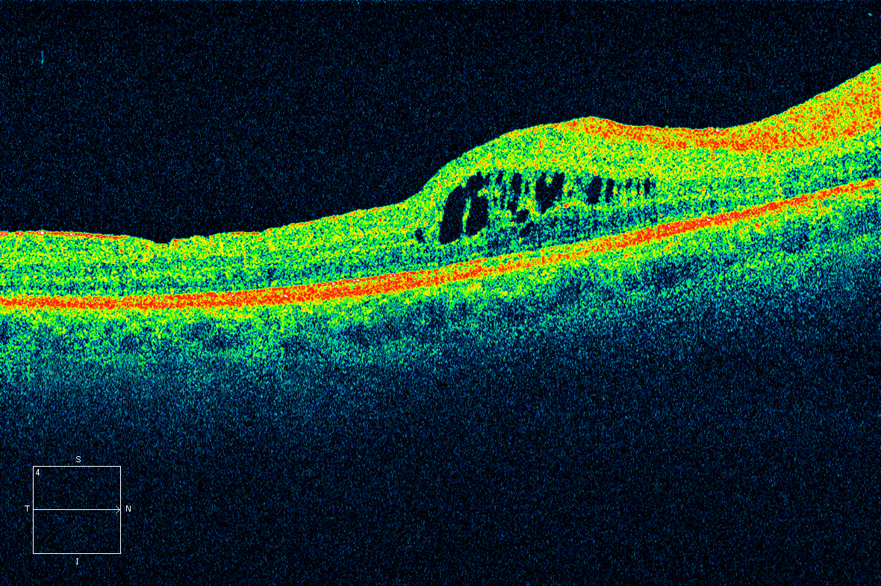
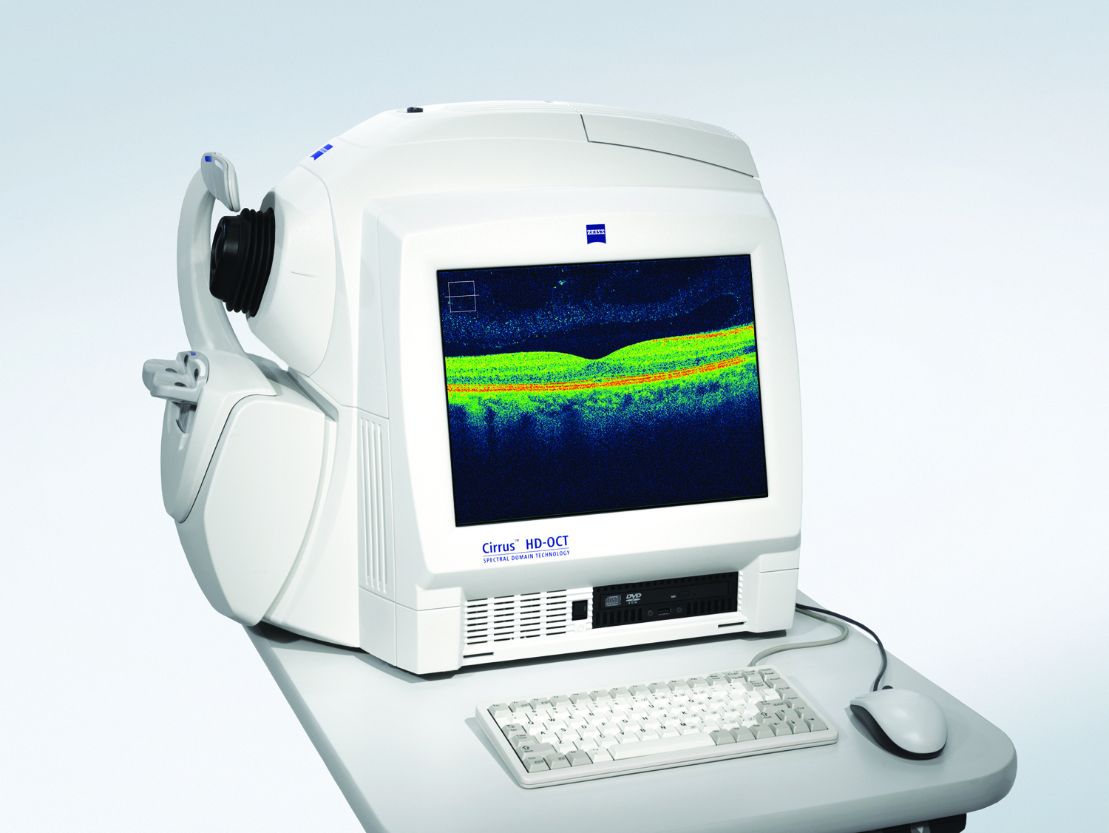
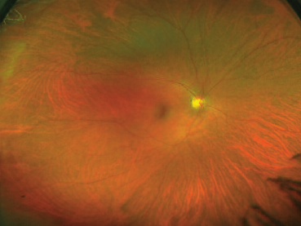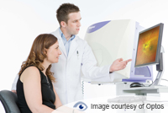
Image of a retina with Diabetic Retinopathy
Healthy Retina (200’) image

The scans provide vital information for the early detection of ocular diseases. Unfortunately, unless we find disease these test are not covered benefits under your insurance. We will submit to your insurance company if any disease is found.

The charge for these scans is $49.00.

